实验报告
2019 年 6 月 6 日 成绩：
姓名 |  | 学号 |  | 班级
专业 | 计算机科学与技术 |  | 课程名称 | 计算机组成原理课程设计
任课老师 | 章复嘉 | 指导老师 | 章复嘉 | 机位号
实验序号 | 实验七 | 实验名称 | 取指令与指令译码实验
实验时间 | 20190525 | 实验地点 | 1-225 | 实验设备号
一、实验目的和实验要求
学习指令存储器的设计；
掌握CPU取指令操作与指令译码的方法和过程；
二、实验程序源代码
`timescale 1ns / 1ps

module Gmips(clk,clr,Inst_code,PC,PC_new,OP,rs,rt,rd,shamt,func);
input clk;//时钟
input clr;//清零

output reg [31:0]PC;//地址
output [31:0]PC_new;
output [31:0]Inst_code;//取出的指令
output [5:0]OP;
output [4:0]rs,rt,rd,shamt;
output [5:0]func;

assign PC_new = PC+4;//组合逻辑电路，不需要时钟控制

always @(*)
begin
if(!clk&clr) PC =32'h00000000;//清零
end

always @(negedge clk)
begin
if(clr) PC<=32'h00000000;//清零
PC = PC_new;//下降沿的时候，把PC_new赋值给PC
end

//实例化模块
Inst_Rom Inst_Rom(
.clka(clk),
.addra(PC[7:2]),
.douta(Inst_code)
);

//拆分指令
assign OP = Inst_code[31:26];
assign rs = Inst_code[25:21];
assign rt = Inst_code[20:16];
assign rd = Inst_code[15:11];
assign shamt = Inst_code[10:6];
assign func = Inst_code[5:0];

endmodule

// Inst_Rom your_instance_name (
// .clka(clka), // input wire clka
// .addra(addra), // input wire [5 : 0] addra
// .douta(douta) // output wire [31 : 0] douta
// );

`timescale 1ns / 1ps

module Top_Gmips(swb,clk,led,which,seg,enable);
input [1:6] swb;
input clk; // 数码管相关
output [2:0] which;
output [7:0] seg;
output reg enable = 1; // 默认开启数码管使能
output reg [1:32]led;
wire [31:0]Inst_code;
reg [31:0]PC;//地址
wire [31:0]PC_new;

//swb[1]模拟时钟，swb[2]清零

Inst_Rom test_Rom(
.clka(swb[1]),
.addra(PC[7:2]),
.douta(Inst_code)
);

Display Display_Instance(.clk(clk), .data(Inst_code),
.which(which), .seg(seg));

assign PC_new = PC + 3'b100;

always @(negedge swb[1])
begin
if(swb[2])
begin
PC = 32'h00000000;
led = PC;
end
else
begin
PC = PC_new;
led = PC;
end
end

// always @(posedge swb[2])
// begin
// if(!swb[1]&swb[2]) PC <= 32'h00000000;//清零
// led = PC;
// end

endmodule

//按下swb[1]时，按下swb[2]不清零，等待swb[1]下降沿清零
//不按swb[1]时，按下swb[2]立刻清零

`timescale 1ns / 1ps
// 8 位七段数码管扫描显示模块
module Display(clk, data, which, seg,
count, digit); // 调试接口
input clk; // 接入系统时钟
input [32:1] data; // 32 位显示数据
output reg [2:0] which = 0; // 片选编码（驱动哪一位数码管），低电平有效
output reg [7:0] seg; // 段选信号（点亮哪些笔划），低电平有效

output reg [10:0] count = 0; // 分频扫描，从左至右循环驱动每一位数码管
always @(posedge clk) count <= count + 1'b1;
always @(negedge clk) if (&count) which <= which + 1'b1;

output reg [3:0] digit; // 显示数据 片选得到 十六进制数码
always @* case (which)
0: digit <= data[32:29]; // 最高位
1: digit <= data[28:25];
2: digit <= data[24:21];
3: digit <= data[20:17];
4: digit <= data[16:13];
5: digit <= data[12:09];
6: digit <= data[08:05];
7: digit <= data[04:01]; // 最低位
endcase

always @* case (digit) // 十六进制数码 转换为 段选信号（a,b,c,...g,dp）
4'h0: seg <= 8'b0000_0011; // 除 g、dp 外全亮，显示数码 0
4'h1: seg <= 8'b1001_1111; // 仅 b、c 亮，显示数码 1
4'h2: seg <= 8'b0010_0101;
4'h3: seg <= 8'b0000_1101;
4'h4: seg <= 8'b1001_1001;
4'h5: seg <= 8'b0100_1001;
4'h6: seg <= 8'b0100_0001;
4'h7: seg <= 8'b0001_1111;
4'h8: seg <= 8'b0000_0001;
4'h9: seg <= 8'b0000_1001;
4'hA: seg <= 8'b0001_0001;
4'hB: seg <= 8'b1100_0001;
4'hC: seg <= 8'b0110_0011;
4'hD: seg <= 8'b1000_0101;
4'hE: seg <= 8'b0110_0001;
4'hF: seg <= 8'b0111_0001;
endcase

endmodule // Display

三、仿真文件和波形图（有就填，没有就不填）
`timescale 1ns / 1ps
//顶层测试模块
module Test_Gmips();
reg clk,clr;
wire [31:0]PC,PC_new;//地址
wire [31:0]Inst_code;
wire [5:0]OP;
wire [4:0]rs,rt,rd,shamt;
wire [5:0]func;

always #25 clk = ~clk;
initial
begin
clk = 1'b0;clr = 1'b1;#25;
clr = 1'b0;#60;
clr = 1'b1;#40;
clr = 1'b0;#90;
clr = 1'b1;#25;
clr = 1'b0;

end
//实例化模块
Gmips Gmips(clk,clr,Inst_code,PC,PC_new,OP,rs,rt,rd,shamt,func);
endmodule
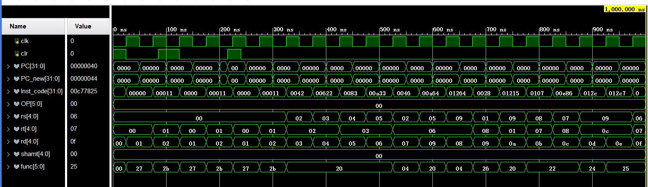
四、电路图（有就填，没有就不填）
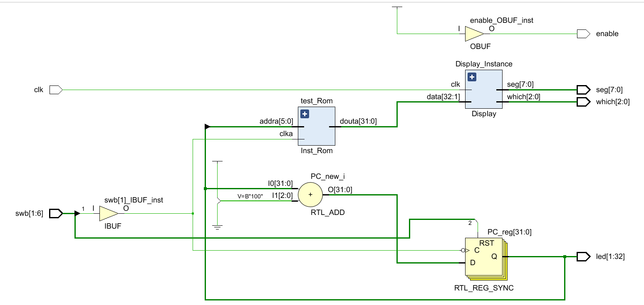
五、引脚配置（约束文件，有就填，没有就不填））
# 开启比特流压缩，优化 .bit 文件大小
set_property BITSTREAM.GENERAL.COMPRESS TRUE [current_design]

# Switch，开关
set_property PULLDOWN true [get_ports sw]
set_property IOSTANDARD LVCMOS18 [get_ports sw]
set_property PACKAGE_PIN T3 [get_ports {sw[32]}]
set_property PACKAGE_PIN U3 [get_ports {sw[31]}]
set_property PACKAGE_PIN T4 [get_ports {sw[30]}]
set_property PACKAGE_PIN V3 [get_ports {sw[29]}]
set_property PACKAGE_PIN V4 [get_ports {sw[28]}]
set_property PACKAGE_PIN W4 [get_ports {sw[27]}]
set_property PACKAGE_PIN Y4 [get_ports {sw[26]}]
set_property PACKAGE_PIN Y6 [get_ports {sw[25]}]
set_property PACKAGE_PIN W7 [get_ports {sw[24]}]
set_property PACKAGE_PIN Y8 [get_ports {sw[23]}]
set_property PACKAGE_PIN Y7 [get_ports {sw[22]}]
set_property PACKAGE_PIN T1 [get_ports {sw[21]}]
set_property PACKAGE_PIN U1 [get_ports {sw[20]}]
set_property PACKAGE_PIN U2 [get_ports {sw[19]}]
set_property PACKAGE_PIN W1 [get_ports {sw[18]}]
set_property PACKAGE_PIN W2 [get_ports {sw[17]}]
set_property PACKAGE_PIN Y1 [get_ports {sw[16]}]
set_property PACKAGE_PIN AA1 [get_ports {sw[15]}]
set_property PACKAGE_PIN V2 [get_ports {sw[14]}]
set_property PACKAGE_PIN Y2 [get_ports {sw[13]}]
set_property PACKAGE_PIN AB1 [get_ports {sw[12]}]
set_property PACKAGE_PIN AB2 [get_ports {sw[11]}]
set_property PACKAGE_PIN AB3 [get_ports {sw[10]}]
set_property PACKAGE_PIN AB5 [get_ports {sw[9]}]
set_property PACKAGE_PIN AA6 [get_ports {sw[8]}]
set_property PACKAGE_PIN R2 [get_ports {sw[7]}]
set_property PACKAGE_PIN R3 [get_ports {sw[6]}]
set_property PACKAGE_PIN T6 [get_ports {sw[5]}]
set_property PACKAGE_PIN R6 [get_ports {sw[4]}]
set_property PACKAGE_PIN U7 [get_ports {sw[3]}]
set_property PACKAGE_PIN AB7 [get_ports {sw[2]}]
set_property PACKAGE_PIN AB8 [get_ports {sw[1]}]

# Switch Button，按钮
set_property IOSTANDARD LVCMOS18 [get_ports swb]
set_property PACKAGE_PIN R4 [get_ports {swb[1]}]
set_property PACKAGE_PIN AA4 [get_ports {swb[2]}]
set_property PACKAGE_PIN AB6 [get_ports {swb[3]}]
set_property PACKAGE_PIN T5 [get_ports {swb[4]}]
set_property PACKAGE_PIN V8 [get_ports {swb[5]}]
set_property PACKAGE_PIN AA8 [get_ports {swb[6]}]

# LED
set_property IOSTANDARD LVCMOS18 [get_ports led]
set_property PACKAGE_PIN R1 [get_ports {led[1]}]
set_property PACKAGE_PIN P2 [get_ports {led[2]}]
set_property PACKAGE_PIN P1 [get_ports {led[3]}]
set_property PACKAGE_PIN N2 [get_ports {led[4]}]
set_property PACKAGE_PIN M1 [get_ports {led[5]}]
set_property PACKAGE_PIN M2 [get_ports {led[6]}]
set_property PACKAGE_PIN L1 [get_ports {led[7]}]
set_property PACKAGE_PIN J2 [get_ports {led[8]}]
set_property PACKAGE_PIN G1 [get_ports {led[9]}]
set_property PACKAGE_PIN E1 [get_ports {led[10]}]
set_property PACKAGE_PIN D2 [get_ports {led[11]}]
set_property PACKAGE_PIN A1 [get_ports {led[12]}]
set_property PACKAGE_PIN L3 [get_ports {led[13]}]
set_property PACKAGE_PIN G3 [get_ports {led[14]}]
set_property PACKAGE_PIN K4 [get_ports {led[15]}]
set_property PACKAGE_PIN G4 [get_ports {led[16]}]
set_property PACKAGE_PIN K1 [get_ports {led[17]}]
set_property PACKAGE_PIN J1 [get_ports {led[18]}]
set_property PACKAGE_PIN H2 [get_ports {led[19]}]
set_property PACKAGE_PIN G2 [get_ports {led[20]}]
set_property PACKAGE_PIN F1 [get_ports {led[21]}]
set_property PACKAGE_PIN E2 [get_ports {led[22]}]
set_property PACKAGE_PIN D1 [get_ports {led[23]}]
set_property PACKAGE_PIN B1 [get_ports {led[24]}]
set_property PACKAGE_PIN B2 [get_ports {led[25]}]
set_property PACKAGE_PIN N3 [get_ports {led[26]}]
set_property PACKAGE_PIN M3 [get_ports {led[27]}]
set_property PACKAGE_PIN K3 [get_ports {led[28]}]
set_property PACKAGE_PIN H3 [get_ports {led[29]}]
set_property PACKAGE_PIN N4 [get_ports {led[30]}]
set_property PACKAGE_PIN L4 [get_ports {led[31]}]
set_property PACKAGE_PIN J4 [get_ports {led[32]}]

# 数码管相关
set_property IOSTANDARD LVCMOS18 [get_ports seg]
set_property PACKAGE_PIN H19 [get_ports {seg[7]}]
set_property PACKAGE_PIN G20 [get_ports {seg[6]}]
set_property PACKAGE_PIN J22 [get_ports {seg[5]}]
set_property PACKAGE_PIN K22 [get_ports {seg[4]}]
set_property PACKAGE_PIN K21 [get_ports {seg[3]}]
set_property PACKAGE_PIN H20 [get_ports {seg[2]}]
set_property PACKAGE_PIN H22 [get_ports {seg[1]}]
set_property PACKAGE_PIN J21 [get_ports {seg[0]}]
set_property IOSTANDARD LVCMOS18 [get_ports which]
set_property PACKAGE_PIN N22 [get_ports {which[0]}]
set_property PACKAGE_PIN M21 [get_ports {which[1]}]
set_property PACKAGE_PIN M22 [get_ports {which[2]}]
set_property -dict {IOSTANDARD LVCMOS18 PACKAGE_PIN L21} [get_ports enable]
set_property -dict {IOSTANDARD LVCMOS18 PACKAGE_PIN H4} [get_ports clk]

# [Place 30-574] Poor placement for routing between an IO pin and BUFG.If this
# sub optimal condition is acceptable for this design, you may use the
# CLOCK_DEDICATED_ROUTE constraint in the .xdc file to demote this message to a
# WARNING. However, the use of this override is highly discouraged.
set_property CLOCK_DEDICATED_ROUTE FALSE [get_nets clk_IBUF]
set_property CLOCK_DEDICATED_ROUTE FALSE [get_nets swb_IBUF[1]]
set_property CLOCK_DEDICATED_ROUTE FALSE [get_nets swb_IBUF[2]]
set_property CLOCK_DEDICATED_ROUTE FALSE [get_nets swb_IBUF[3]]
set_property CLOCK_DEDICATED_ROUTE FALSE [get_nets swb_IBUF[4]]
set_property CLOCK_DEDICATED_ROUTE FALSE [get_nets swb_IBUF[5]]
set_property CLOCK_DEDICATED_ROUTE FALSE [get_nets swb_IBUF[6]]
七、实验收获（心得体会等，请以个人为单位分别写）
- pc_new=pc+4;为组合逻辑电路，与clk无关
- pc=pc_new在clk下跳沿赋值
- verilog允许多个always语句并行，采用两个always语句，使得在clk为1时，rst信号需等待clk下跳沿，clk为0时，rst信号立即清零。
- 但是不知道为啥，仿真实现rst等待信号取完的清零功能，板卡却一直出现神秘错误。
- 所以板卡采用的Top_Gmips是同步清零。

